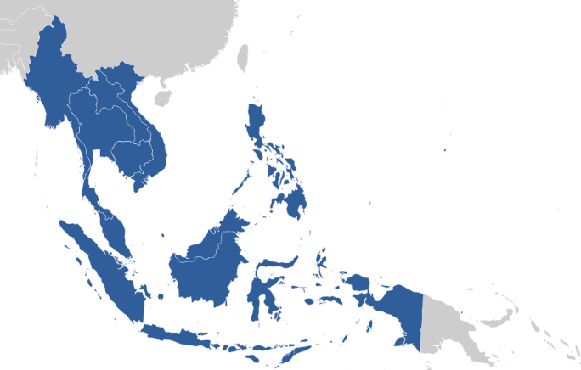
2015 Fall School in Empirical Research Methods
convened by
Southeast Asian Studies at Freiburg University (www.southeastasianstudies.uni-freiburg.de)
in collaboration with the Global Studies Programme (GSP) and the Center for Transcultural Asian Studies (CETRAS)

Registration Form
for the Southeast Asian Studies’ Fall School in Empirical Research Methods,
29 – 31 October 2015

Name and Email Address:

Faculty and Status (e.g. PhD student):

Research Project (research topic and state of research):

Which techniques have been used/ will be used for empirical inquiry and analysis?

What would you like to learn or discuss? (specific questions, interests etc.)

I would like to take part in the workshop(s):

Working with Quantitative Data
Area Studies and Concept Formation in the Social Sciences
Qualitative Comparative Research
Analyzing Qualitative Interviews
Discussion of and advice for participant’s own research projects

Please apply by sending the registration form to anna.fuenfgeld@politik.uni-freiburg.de until 16 October 2015.

